A California Nonprofit Public Benefit Corporation

2024 Visual & Performing Arts Educational Grants
Application Instruction Sheet

Dear Applicant:

The Martin Luther King, Jr. Community Choir San Diego (MLKCCSD) is pleased to announce its twenty-second annual educational grant awards. If you are a graduating senior with a GPA of 2.75 or better, if you live in San Diego County and are a U. S. citizen, if you are passionate about and committed to your chosen field in the creative arts, and if you intend to major in this field at an accredited institution of higher learning, we urge you to apply for one of our grants!

To apply, fill out the attached Personal Information Sheet. Add to that the items listed below. Then mail everything to us. And make sure your school mails us your transcript and GPA. MOST IMPORTANT, MAKE SURE EVERYTHING IS POSTMARKED BY March 20, 2024. Our mailing address is:

Martin Luther King, Jr. Community Choir San Diego
Educational Grants Committee
P.O. Box 152570, San Diego, CA 92195

You need to submit the following items: (Please check off each item as you assemble your application.)
- Personal Information Sheet (Remember, you and your parent/guardian must sign.)
- Personal Essay (See instructions on Personal Information Sheet.)
- Two Reference Letters (At least one from school. Family members cannot serve as references.)

You need to submit the following form to your school:
- Authorization to Release Information (You and your parent must complete and sign the top portion first. The school clerk/official must complete and sign the bottom portion second.)

Your school needs to send the following items to us:
- Transcript
- Authorization to Release Information (Your school must finish completing the form and it must be signed by a school clerk/official.)

Any Questions? Call Shelly Parker at 619-733-5399 or email mlkccsdedugrants@gmail.com.

Finalists: Each FINALIST will be required to submit a five-minute electronic presentation of their art by
April 10th; and will participate in a Zoom interview on May 18thor May 25th, so please plan accordingly. *Participants may be videotaped, with parent/guardian written permission, during the personal interview. *Please be advised that the above interview dates have been pre-arranged, but could be subject to change due to circumstances beyond our control.

MLKCCSD PURPOSE: We are a nonprofit charitable organization. The MLKCCSD established the Visual & Performing Arts Educational Grants to support graduating high school seniors who will be majoring (at an accredited college, university or conservatory) in the areas of visual and performing arts. These grants are available to all San Diego County high school seniors, who are U. S. citizens, regardless of race, ethnicity, religion or sex. Our educational grants have been designed to assist students of exceptional talent, especially those who demonstrate a financial need. Each educational grant typically ranges from $1,500 to $3,500. Multiple grants are awarded each year. Visit our website at: www.mlkccsd.org for additional applications and/or information.
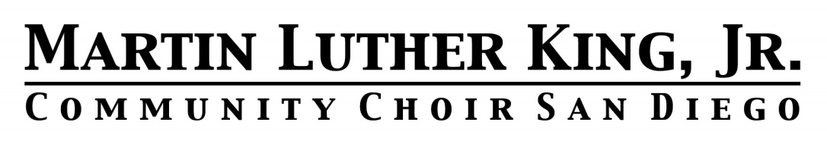
A California Nonprofit Public Benefit Corporation

2024 Visual & Performing Arts Educational Grants
Personal Information Sheet

Name: _______________________________________________________ DOB: _______________
Address: _________________________________________________ Phone: ___________________
Street City Zip Code

Frequently Checked Email Address: ______________________ Cell Phone: ___________________

High School: _______________________________ Graduation Date: ____________ GPA: _______

Annual Family Income: __________ Family Members Living at Home: Adults____ Children ____ (Fill in number of adults and number of children, including yourself.)
Are you a United States citizen? Yes ___ No ___
PLEASE DO NOT APPLY UNLESS YOU WILL MAJOR IN
ONE OF THE CREATIVE ARTS
Review the below choices and check ONLY ONE.
__Performing Artist, __Visual Arts, __Performing Arts, __Multimedia, __Literary Arts, __Digital Arts

What will your major/minor be in college?

Major______________________Minor______________________Other_________________________
Tell us about your jobs, volunteering, community activities, hobbies and awards:
(If necessary, you may attach a separate sheet) ___________________________________________________ _________________________________________________________________________
Please list two references: (At least one reference must come from your school. Family members may not be used as references.)
Teacher or School Staff: _______________________________________ Phone: ___________________
Community or School: _______________________________________ Phone: ___________________
Attach a personal essay: Tell us about yourself and your aspirations for the future. (This essay is required and should be at least 500 typewritten words.) If you’d like, you may attach a resume or a list of your accomplishments.

I declare that all the information I have provided in this application is true and accurate to the best of my knowledge.

________________________ ________ ________________________ _______
Student Signature Date Parent/Guardian Signature Date

Applications must be postmarked by March 20, 2024

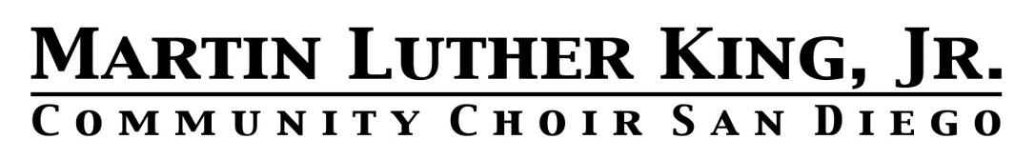
A California Nonprofit Public Benefit Corporation

2024 Visual & Performing Arts Educational Grants
Authorization to Release Information

This information is to be completed by student: (Please print)

I hereby authorize _______________________________________________________ to release the
(Please print name of high school)

information requested below to the Martin Luther King, Jr. Community Choir San Diego.

Student: _____________________________________________________________ DOB: _________
(Please print name of student)

________________________________________________________ _______________________
Student Signature Date

________________________________________________________ _______________________
Parent/Guardian Signature Date

*************************************************************************************

This information is to be completed and mailed to MLKCCSD by school:

Grade Point Average: ______________________________

Expected Date of Graduation: ________________________

Transcript: (please attach)

_______________________________________ _________________________ ___________
Signature of School Clerk/Official Title Date

Please Submit Information to:
Martin Luther King, Jr. Community Choir San Diego
Educational Grants Committee
P.O. Box 152570, San Diego, CA 92195

Information must be postmarked by March 20, 2024

